

BUSINESS CASE

FOR

New Computers

Preparation Date | Document # | Revision # | Approved by | Prepared by

Contents

Contents 2

1 Executive Summary 3

1.1 Executive Summary Purpose 3

1.2 Solution Overview 3

1.3 Stakeholder Analysis 3

1.4 Assumptions 3

1.5 Constraints 3

1.6 Requirements 3

1.7 Alternative Analysis 4

2 Project Recommendation 4

2.1 Schedule/Milestones 4

2.2 Risks 5

3 Justification 5

3.1 Benefits 5

4 Organizational Impact 5

4.1 Impact 5

4.2 Personnel Requirements 6

5 Cost Benefit Analysis 6

5.1 TCO 6

6 Conclusion & Recommendation 6
Information contained within this document is proprietary. The information may not be copied, reproduced or disclosed, in any manner, whole or in part, without prior written permission.

Executive Summary

Executive Summary Purpose
The current Desktop systems that the company is still using is completely outdated and, in our generation, there are better systems that exists that allows us to work at an extremely efficient manner. The systems we are currently using are so old that they slow down the entire business operation. We gain several complaints from multiple departments that the processing speed is either too slow or it just crashes, and they receive nothing. These issues in turn lead to a slow production and manufacturing rate. Our software development will not advance as fast as it should be, and our logistics will go down and all these factors will lead to an increasing cost to our customers which will decrease customer satisfaction as well.

Solution Overview
First, we determine the number of computers which should be 11,550 with the 10% increase in computers as backup in case one system has an issue. Then we search for a vendor that is able to sell the specs that we require and within our budget of 2.8 in the first year and 12.3 mill over three years where each system must be 500$ or less. We then contact the vendor, schedule a delivery date. Once we receive our new systems, we make sure we have updated the software, include updated Microsoft Office and make sure the system does not feel very unfamiliar.
We then train our employees and make sure we calculate our ROI and find out if these new systems lead to lower costs from customers and higher revenue for the company. and we also need to evaluate risks which will be talked about below.

Stakeholder Analysis
Name | Role in Org. | Level of Impact/Influence  High or Low | Attitude about Project  For or Against
Anna Litical | CIO | High/High | For
Allie Gater | Accounting | High/High | For
Perry Scope | Operations | high/Low | For
Dee Mandinboss | Marketing | High/low | Against
TY Tannick | Hr. | Low/low | against

Assumptions

The new computers will have the required components and at a price of 500 or less.

The budget should be 2.8 million for the first year and 12.3 million over the course of 3 years

The systems will arrive on schedule

The new computers will provide restrictions and administrative privileges

A few of the computers must be portable to allow employees to work remotely

The new systems won’t affect our policies and regulations.

Constraints
Top boundary: 2.8 million on the first year and 12.3 million over three years

Must be completed not over 3 years

Price of a system must not be over $500

Our ROI must be at least 64%
Floor: System must have I7 core or newer

16 GB of RAM or more

1 TB SSD or more

Requirements

Functional Requirements:

The system shall have at least an I7 processor

The system shall have at least 16 GB RAM

The system shall have at least 1 TB SSD

The system shall have at least 32 GB RAM for accounting department

The system shall be compliant with the Sarbanes Oxley act of 2002.

The system shall have at least 20 TB database size for operations

The system shall have at least 16GB GPU for operations department

The system shall have DVD drives to load and run CAD software

The system shall have access to SaaS programs

The system shall have access to Microsoft Office

The system shall comply with HIPPA regulations.

The system shall have the capability to store old records and data.

Non-Functional Requirements:

(Remove all this text to put your information in) List out all Non-Functional requirements, anything that does not impact the functionality, such as security, again use the words shall

EXMPLE: The system shall have an easy to use common user interface for ease of access and familiarity in usage when switching between programs
The system shall have security functions

some systems shall have portability functions to allow remote work

The system shall have Familiar processes to the old

Alternative Analysis
No Project (Status Quo) | Reasons for Not Selecting Alternative
Keep the current system | The reason why we should not keep the current system is because our system is too old that it slows down the processing time or even crashes so it takes forever to process which then leads to higher manufacturing time and then we will be forced to increase costs for customers because we want to have a good ROI.
Alternative Option | Reasons for Not Selecting Alternative
Solution #2 Thin client | The reason why we should not choose this option is because it is a server based environment so we would have to purchase new servers to keep collections of old records and we will have to purchase DVD and USB to store specific information which already increases our costs another issue could be in security since every information is on a server if anything happens to that server it could wipe the company entirely sure we could have backup but that would cost us even more and we will have to increase the prices of our products even more.
Alternative Option | Reasons for Not Selecting Alternative
Solution #3 BYOD | The reason as to why BYOD was not chosen is mostly because of security reasons. Even though BYOD can help reduce costs where we don’t have to buy new systems this could increase processing time in IT because they will have to scan every single device for any sensitive information that an employee may have stored and if by any chance an employee has sensitive information anyone could hack their computer or they may sell it (insider information) which will give other companies competitive advantage over us and reduce our revenue.
Chosen Solution
Implement new systems

Project Recommendation

Schedule/Milestones
(Insert a screen shot of MS Project schedule)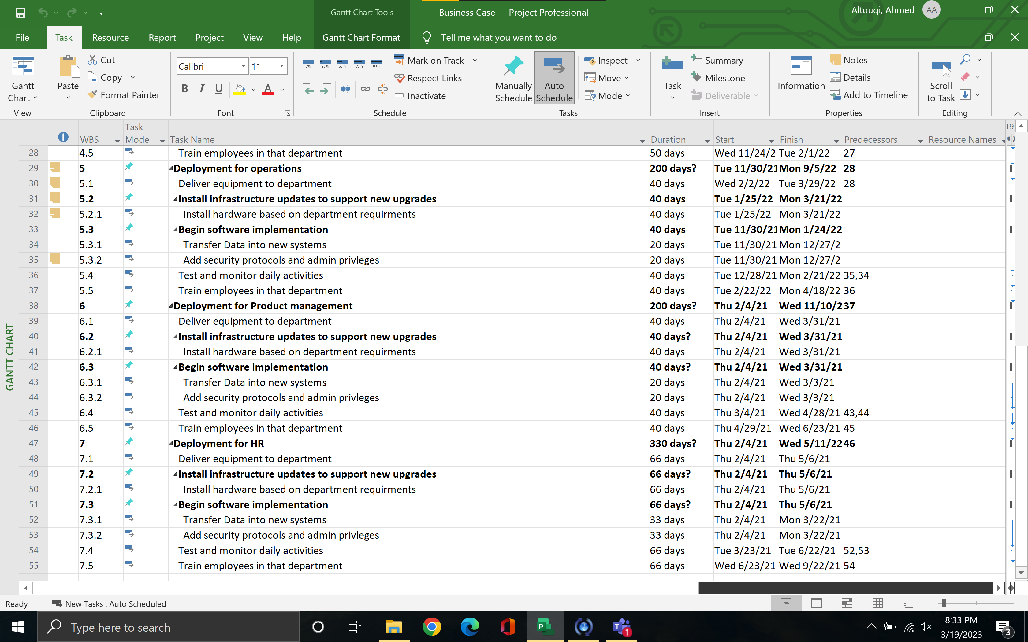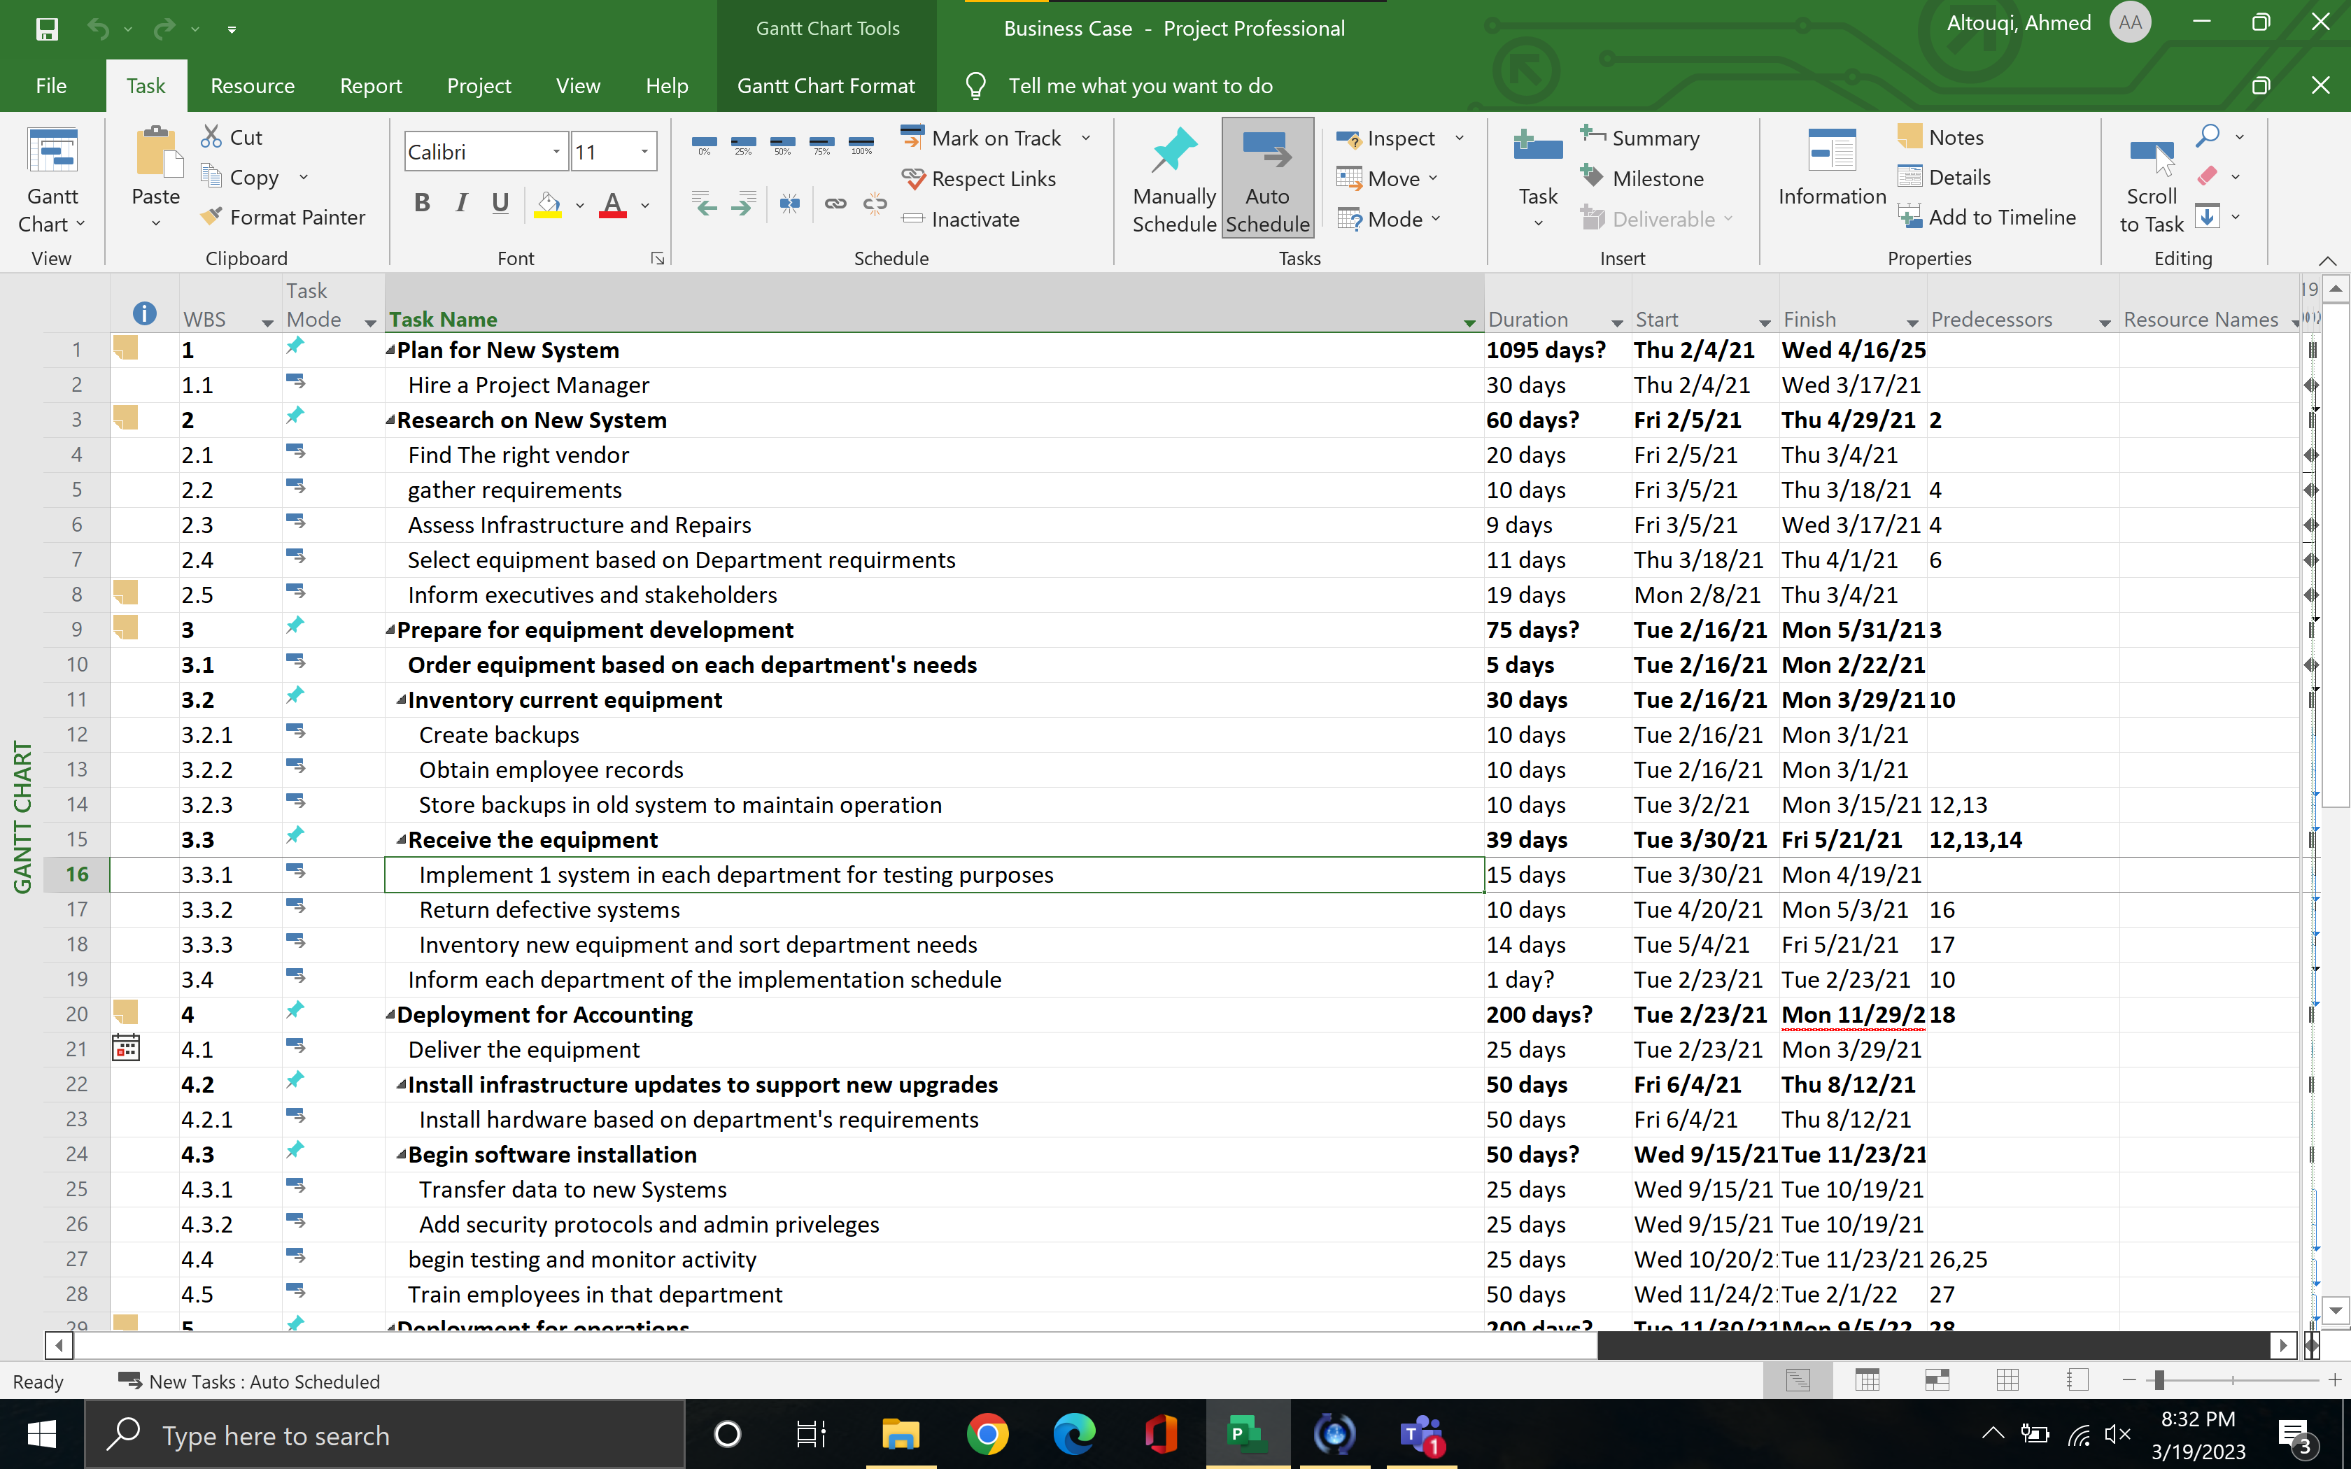

Risks
(Risk score is Frequency multiplied (Do NOT touch this table; Entries are in the next table)
Frequency | Numeric | Description |  | Severity | Numeric | Description
Frequent | 5 | Happens most of the time |  | Catastrophic | 5 | Failure of project
Probable | 4 | Will probably happen |  | Critical | 4 | Potential for severe delay
Occasional | 3 | May happen in some form |  | Moderate | 3 | Potential for moderate delay
Remote | 2 | Possible but unlikely |  | Minor | 2 | Potential for minor delay
Improbable | 1 | Very unlikely to happen |  | Negligible | 1 | No significant delay

(What are the risks that can keep the project from being completed? Risk score= Frequency x Severity)
Risk # | Risk Name | Description | Factors | Effect | Freq | Sev | Risk Score | Trigger | Mitigation | Contingency
1 | Hardware | Hardware may not show up on time | Using new vendor | May cause schedule delay | 3 | 3 | 9 | Vendor provides receive date later than required | Contact vendor to find out lead time for early ordering | Order from Secondary Vendor and pay for overnight shipping
2 | Hardware | Components do not matc3h | Use new vendor (Sue previous vendor) | May cause a delay | 1 | 4 | 4 | Vendor may receive wrong specs | Contact vendor and update specs | Order from a secondary vendor
3 | Budget | Went over the budget | Higher system prices | May increase costs | 2 | 4 | 8 | Specs are rare to find or out of stock | Order ahead of time and keep checking the availability of specs | Order a system with a slightly higher or lower specs.
4 | Security | Privileges and restrictions set | System is not compatible with security software | May cause leaks | 2 | 5 | 10 | System is not in compliance with our security software | Contact vendor of our security software and make sure it is compatible | Switch to a different security software.
5 | Hardware | Some systems are remote others are not | New vendor | May lower production as some departments do not allow remote | 1 | 4 | 4 | Vendor may sell more laptops than desktops | Contact vendor ahead of time and state we need more desktops than laptops | Sell laptops and purchase new desktops.

Justification

Benefits
Every department in this company will be able to benefit from these new systems. It will ensure that every department within the organization will have the most efficient processing time which will allow them to have higher production rate and increase our revenue.
The new systems will help boost employee morale because they are not having to go through extreme processing times anymore. These new systems will have upgraded UI and max speed processing times allowing them to do their work in an efficient manner.
Not only employee morale will increase but the customer as well because then the company will be able to lower the prices of the product because the company will be able to provide more at a lower cost than before.
This will open to new innovation as now our software development rate has increased, we are now capable thanks to the power of our new system be able to test out different software/AI and that will also lead to competitive advantage.

Organizational Impact

Impact
The first thing we would have to do Is hire a project manager. Every project needs a manager to start up the project they will be the ones to oversee the project and make sure everything is running as planned based on the business case.
A security analyst is also required because now that we have new systems, we need to make sure that old records and data can be transferred and stored securely in our new systems, and admin privileges and restrictions are set on specific departments to protect information.
A trainer is required to train the employees to use these current systems as most likely they will be new features and some familiar features as well so the trainer will train a number of employees per year so that they know everything related to the system and quickly workaround an issue if they come across one.
the policy changes such as the Sarbanes Oxley act and HIPPA regulations which we must follow.

Personnel Requirements
(How many individuals are proposed for this project and what are their skill sets (best to insert a two column table (Type of person (engineer, project manager, etc) and their cost… Labor cost is hourly not annually)
Type of Personnel | Burdened Labor Cost = hourly cost plus 50%
Project Manager | $100
Desktop Support | $80
Sever maintenance | $120
Trainer | $50
Security Analyst | $90
Customer Support | $50

Cost Benefit Analysis

TCO
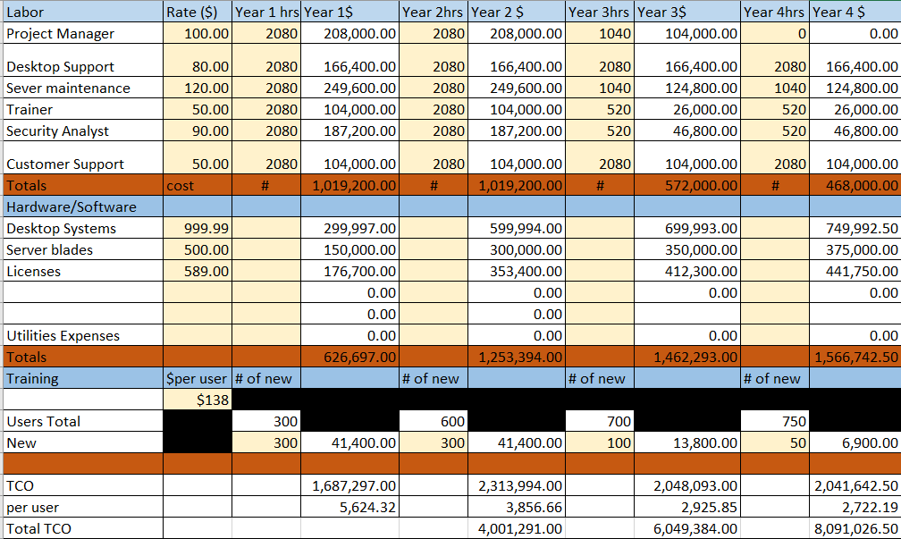

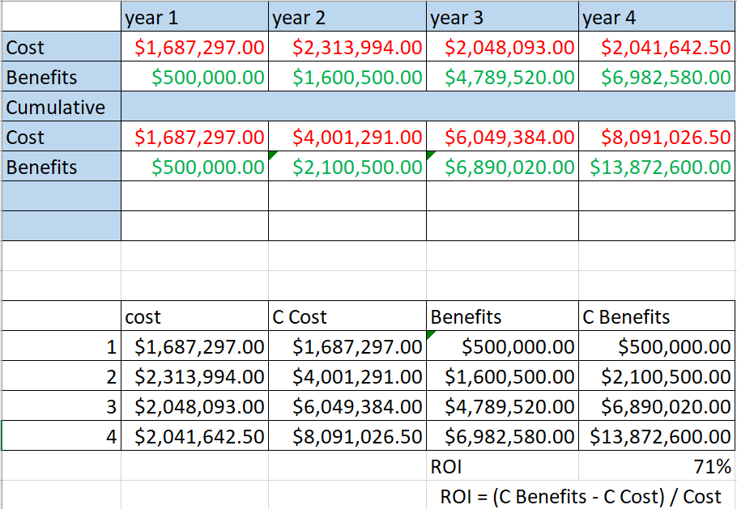

Conclusion & Recommendation
(Remove all this text to put your information in) Provide your conclusion & recommendation here.. Brief overview of situation, chosen solution, costs, benefits, changes to org and any other reason you are recommending this project) (AND Cite any websites, articles you used for research during the building of this business case)
To summarize, our company heavily requires the implementation of these new systems. The Company is falling behind due to the use of old computers which lowers processing and in the long run lower our revenue. we won’t have any competitive advantage because the old machines are not strong enough to compete with what our competitors are using. So, investing in a new machine helps eliminate that and provide great prices to our customers. The pros do outweigh the cons in this situation and there may be some remarks made by other employees from other departments, but I do think that is should be a top priority emergency. Benefits do include high customer morale, better feedback, more new customers and also will improve the working environment. And based on statistics we will be making an ROI of 71% which is more than the 64% that we require. So that is why I recommend in bringing new computer systems in.

